Logistic Regression Exercise
Scenario
You're helping a Cameroonian bank predict whether a loan applicant will default (fail to repay) based on two features: their monthly income and existing debt amount.

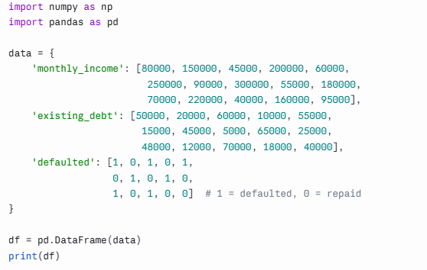

Tasks
1. Explore the data
- Print df.describe() to see the summary statistics
- Count how many people defaulted vs repaid using df['defaulted'].value_counts()
2. Prepare the data
- Split into features (X) and target (y)
- Use train_test_split (80% train, 20% test)
3. Train a Logistic Regression model
- Fit the model on the training data
- Print the model's coefficients (model.coef_) and intercept (model.intercept_)
4. Make predictions
- Predict on the test set using model.predict(X_test)
- Also try model.predict_proba(X_test) — this shows the actual probability for each class instead of just 0 or 1
5. Interpret one applicant
- Pick a new hypothetical applicant: income = 100,000, debt = 40,000
- Predict whether they'd default, and print the probability

